SQL Learning



Nithish Gowda

Comparison operator

Operator description

= equal to

!= or <> not equal to

> greater than

< less than

>= greater than or equal

<= less than or equal

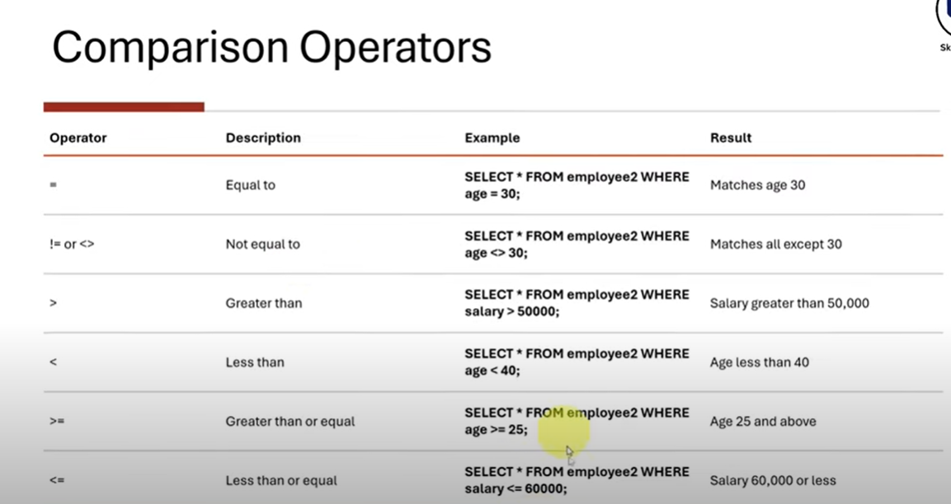

**-----comparison operator----------------**

**----show all age >30 , employees----**

**select * from csvsql**

**where age=30 ;**

**-----matches all age expect 30 -------**

**select * from csvsql**

**where age<>30 ;**

**select first_name , age from csvsql**

**where age<>30 ;**

**----salary where greater than 50k--------**

**select * from csvsql**

**where salary>=50000;**

**select * from csvsql**

**where salary<=50000;**